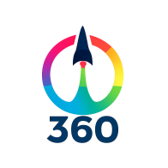  **Jovan Spasojevic : spaskekl@gmail.com**

**Worldwide 360 Virtual Tour Development Service**

# **[ Company Email :** [jovan.spasojevic@360virtualtour.pro](mailto:jovan.spasojevic@360virtualtour.pro) **] [ Service Url : <http://360virtualtour.pro> ]**

**Abstract**

Our service creates immersive virtual tours for all types of hotels, allowing potential guests to explore your property online. These virtual tours provide an interactive, detailed experience, letting users navigate through rooms, amenities, and common areas from the comfort of their homes. We seamlessly integrate these virtual tours into your hotel’s website, ensuring there are no changes to its design or layout. This solution enhances guest engagement by offering a modern, online experience that is both dynamic and easy to navigate. The virtual tour builds trust by providing a realistic, in-depth look at your hotel, helping potential guests feel confident in their booking decisions. As a result, hotels that use virtual tours see an increase in bookings and conversion rates. Our platform is easy to use, requiring no technical expertise, and works for all types of hotels, from boutique to luxury. By offering this innovative feature, your hotel stands out from competitors and stays ahead of industry trends. Virtual tours create a unique, interactive experience that draws in a wider audience of travelers. Ultimately, integrating a virtual tour into your website is a powerful tool to attract guests and drive more reservations.

*Keywords*: Virtual Tour, 360 Degree Panorama, all types of hotels

# Introduction

Our team specializes exclusively in creating immersive virtual tours for hotels, transforming how potential guests experience properties remotely. We began with the goal of offering an interactive and detailed look at hotels, as traditional photos and descriptions often weren’t enough. By integrating 360° photography and interactive media, we allow guests to virtually explore rooms, amenities, and common areas at their own pace, providing a personalized experience that showcases the true essence of each hotel. Our tours seamlessly integrate into hotel websites, maintaining the original design and requiring no technical expertise, ensuring a smooth process for hoteliers. Whether it’s a luxury resort, a boutique hotel, or a budget-friendly property, we tailor our tours to highlight each hotel’s unique offerings, from exclusive amenities to intimate atmospheres. Our services have proven to increase guest confidence, leading to higher conversion rates and more bookings. By expanding the reach of hotels to a global audience, our tours allow travelers worldwide to explore at their convenience, breaking down geographic barriers. Over time, we’ve enhanced our tours with features like interactive hotspots, multimedia elements, and background sounds, ensuring the experience is not only informative but also engaging. The tours are fully responsive across all devices, ensuring a seamless experience whether viewed on desktops, tablets, or mobile phones. Smooth navigation and intuitive transitions make our virtual tours feel like walking through the hotel in person. We’ve had the privilege of working with various hotel types, constantly refining our approach to meet their specific needs. Our commitment to innovation has positioned us as a trusted partner in the hospitality industry, helping hotels stand out in an increasingly competitive market. With a focus on high-quality, immersive experiences, we continue to push the boundaries of virtual tour technology, exploring new features like virtual reality (VR) and augmented reality (AR). We adapt to meet the ever-changing needs of the hospitality industry, continually enhancing our services to ensure hotels stay ahead of industry trends. By providing virtual tours, we help hotels build trust with potential guests, showcasing their properties in a way that encourages bookings. Our tours serve as powerful marketing tools, drawing in more visitors and creating lasting impressions. The positive feedback we receive from our hotel clients and their guests speaks to the impact of our work, making virtual tours an essential part of the hotel marketing strategy. We remain dedicated to helping hotels, no matter their size or budget, provide the best online experience for their guests, increasing engagement, driving bookings, and staying ahead of the competition.

# The main benefits

- Increased Guest Confidence A virtual tour lets potential guests see exactly what the hotel looks like, building trust and reducing uncertainty about their stay.

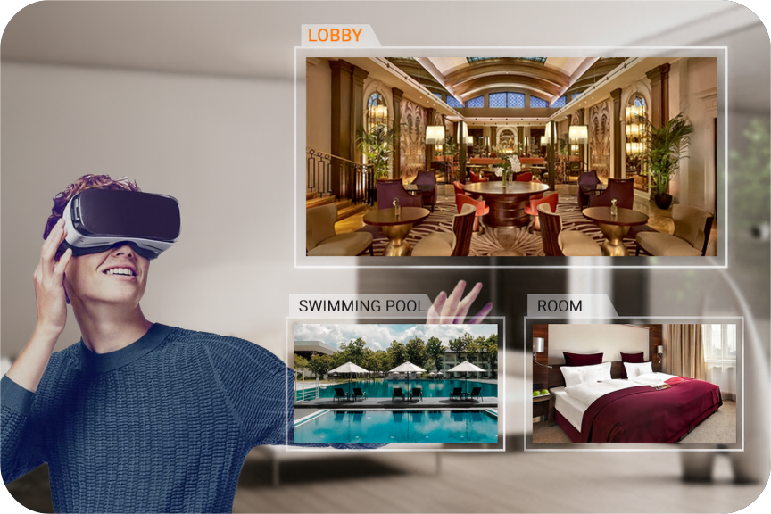

- Higher Engagement and Bookings Guests spend more time exploring the hotel online, leading to higher booking rates and better engagement on the website.

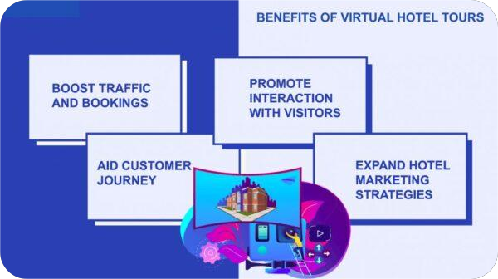

- Wider Reach and Accessibility Guests from anywhere in the world can explore the hotel at any time, increasing the hotel's visibility to a global audience.

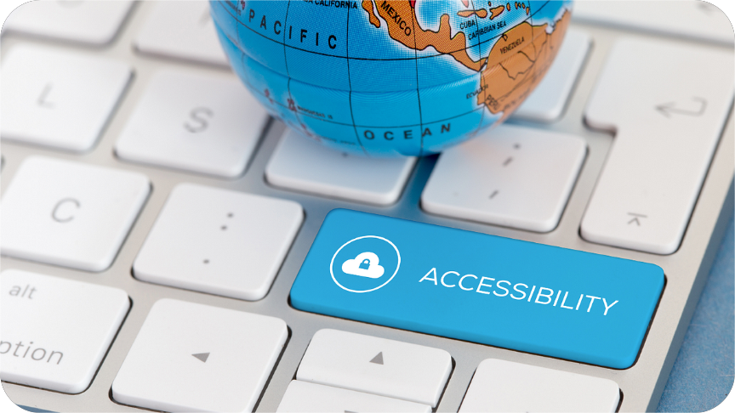

- Cost and Time Efficiency Virtual tours reduce the need for in-person visits, saving time and resources for both the hotel and potential guests.

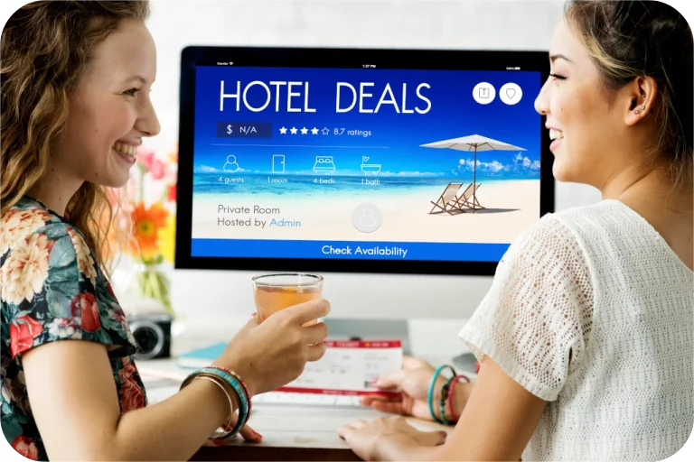

1. **Where can be applied**

This service can be applied to all types of hotel websites, significantly enhancing the overall user experience. By offering virtual tours, it allows potential guests to explore the property from the comfort of their own home.

- For Luxury Resorts

Luxury resorts can use virtual tours to showcase their opulent suites and sprawling grounds. This gives high-end guests a preview of the extravagant experience awaiting them. They can also highlight exclusive amenities like spas, fine dining options, and expansive outdoor spaces

- For Boutique

Hotels Boutique hotels can highlight their unique design, personalized amenities, and distinct character. A virtual tour helps convey the special, intimate experience that boutique accommodations provide. This helps guests feel the charm and individuality of the property before making a decision.

- For Budget-Friendly Hotels

Budget-friendly hotels can use virtual tours to showcase their cozy rooms and inviting common areas. This gives guests confidence that they are getting value for money. Highlighting the comfort and cleanliness of the rooms helps reassure potential guests.

- For Small Hotels

Small hotels can benefit by featuring local attractions and points of interest in their virtual tours. Guests can virtually explore the neighborhood and get a feel for the surrounding area. This provides insight into the hotel’s location and convenience for activities nearby.

- For Bed-and-Breakfasts

Bed-and-breakfast establishments can create personalized tours to give guests a more intimate, homey feel. These virtual experiences make guests feel more connected to the property even before they arrive, fostering a sense of belonging and comfort.

- For Larger Chains

For larger hotel chains, virtual tours help create a consistent and high-quality online presence across all properties. This fosters trust and brand recognition, ensuring guests feel confident in choosing a location within the chain.

- Interactive Elements and Exploration

Virtual tours can include interactive elements, allowing guests to explore different parts of the hotel at their own pace. They can view the lobby, rooms, amenities, and outdoor spaces without feeling rushed.

- Convenience and Accessibility

Guests have the flexibility to take the tour at their own convenience, avoiding the need for additional calls or emails for more information. The interactive format is both informative and user-friendly.

- Competitive Advantage

Offering virtual tours helps hotels stand out in a crowded market. It provides a modern and engaging way for potential guests to experience the property, boosting online engagement.

- Increased Booking Conversions

By creating a more engaging online experience, virtual tours can significantly increase the chances of converting site visits into actual bookings. This allows hotels to capture the attention of tech-savvy travelers who value convenience.

- Meeting Guest Expectations

Hotels that offer virtual tours align with the expectations of today's travelers, who are accustomed to technology and prefer digital interactions. This feature can meet their desire for transparency and a more immersive online experience.

- Attracting More Bookings

Any type of hotel—whether it’s a luxury resort, boutique hotel, or a small bed-and-breakfast—looking to improve online engagement can benefit from incorporating virtual tours. The feature attracts more bookings by offering guests a comprehensive look at what they can expect during their stay.

# Who will carry it out, where, and how?

We are contacting platforms like SeekBeak, Kuula, Panoee, TeliportMe, Concept3D, 3DVista Virtual Tour Suite, Matterport, and P4Panorama to create immersive, interactive experiences for users. We stitch panoramic images of destinations and integrate interactive hotspots, allowing users to easily navigate through different areas of the tour. We support seamless keyboard navigation, enabling users to explore the tour using arrow keys for smooth, intuitive transitions between scenes. The integration of background sounds, narrations, and multimedia elements further enhances the experience, making each virtual tour feel more engaging and lifelike.

We provide custom branding and control over the design, offering a unique look and feel for each tour. Additionally, our design ensures the tours are easily accessible across different devices, from desktops to mobile phones. We continuously improve the user experience.

Through usability testing, we've fine-tuned the navigation speed, image quality, and interaction flow, ensuring the tour experience is both fast and visually stunning. With the ability to add videos, 360° images, and other media, we create highly customized virtual tours tailored to the needs of our clients. Overall, we make it an ideal choice for building dynamic and user-friendly virtual tours for any industry.

# Product Overview

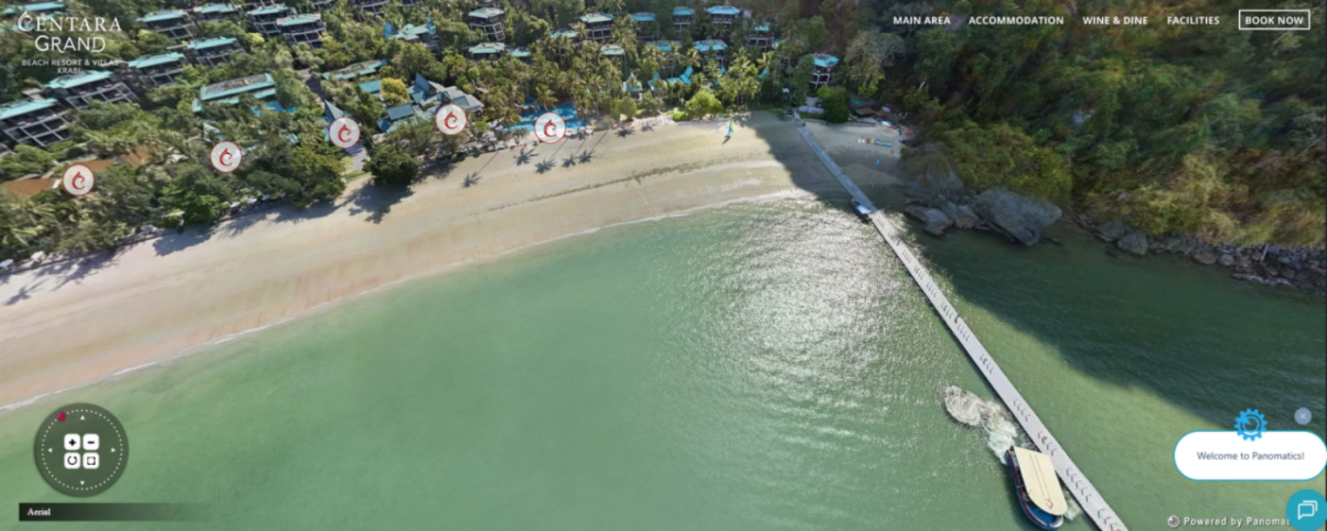

This type of virtual tour can give guests the feeling of flying in the sky.

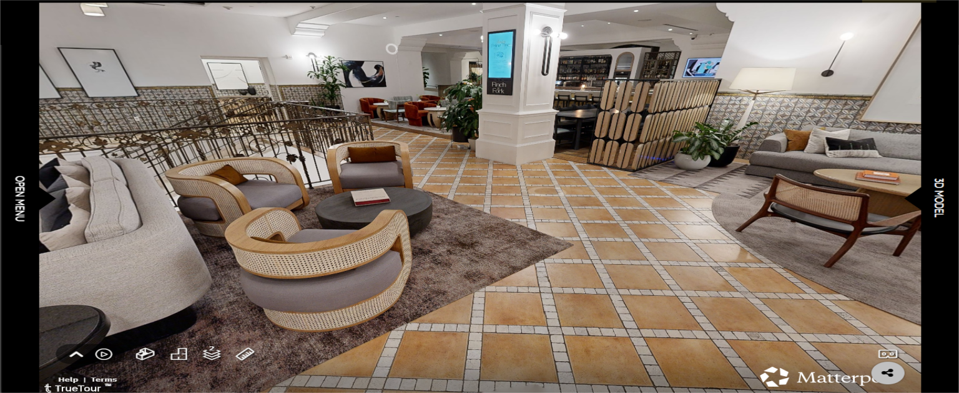

Guests can virtually walk around the resort as if they were actually there.

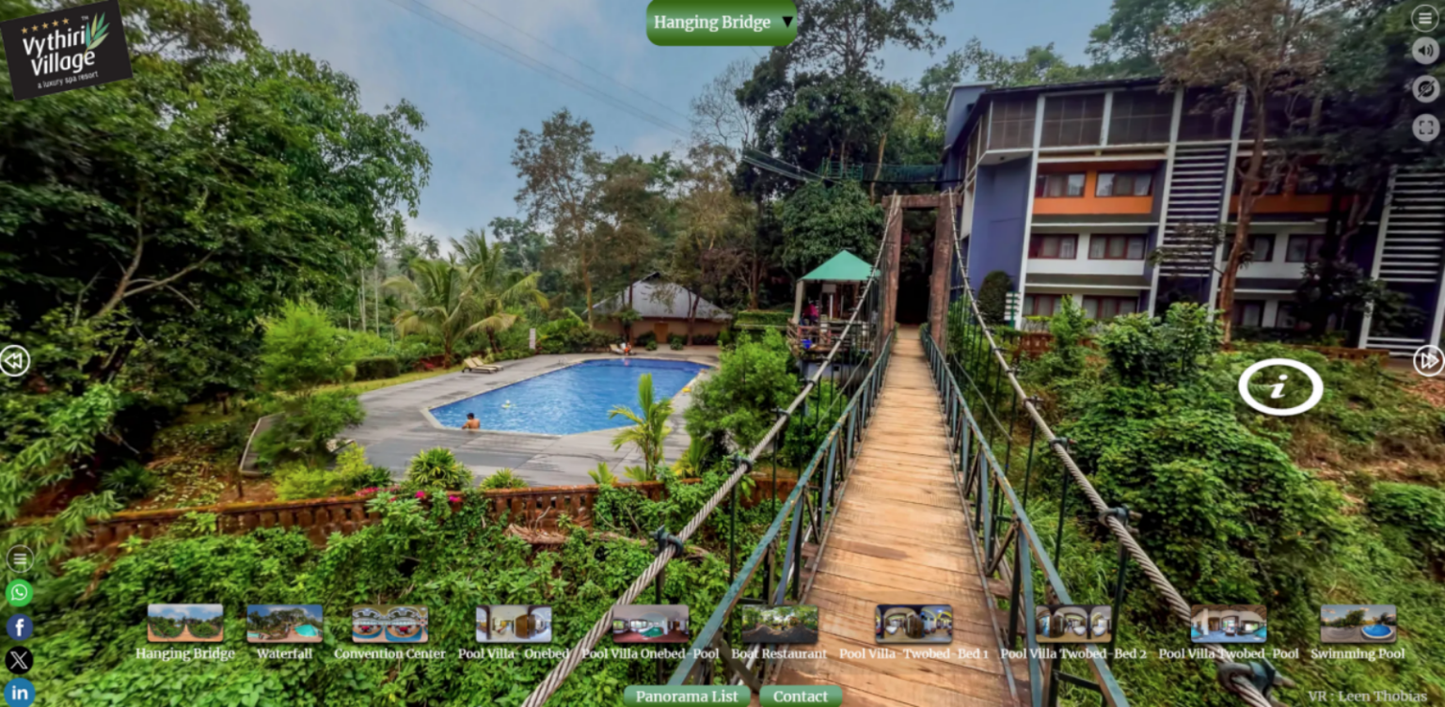

Here, guests can virtually walk along the hanging bridge and enjoy the stunning view of the resort and pool.

- Here are some URLs to virtual tours we’ve developed. Feel free to explore them now!

<https://www.hotelmontecristoparis.com/virtual-tour>

_______________________________________________________________________________________________________

<https://www.thelondoner.com/about-us/virtual-tour>

_______________________________________________________________________________________________________

<https://my.matterport.com/show/?m=Gjk6pHkDH7W&ss=253&sr=3.14,-.56>

_______________________________________________________________________________________________________

<https://www.p4panorama.com/gallery-item/the-vythiri-village-resort-wayanad/>

_______________________________________________________________________________________________________

<https://visitingmedia.com/tt8/?ttid=kimpton-canary-hotel#/3d-model>

_______________________________________________________________________________________________________

# Results and Discussion

After testing the validation and reliability of the usability virtual tour questionnaire data, then a descriptive analysis is carried out on all usability indicators. The virtual tour site was shared with 50 random users. Then the usability tests were conducted to receive user feedback and to measure the usability of the product including user satisfaction and product effectiveness. The usability tests were conducted from users' smartphones or personal computers. They were given 10 minutes to explore the hotel virtual tour. Besides the questionnaire, the open question was delivered to users to gain suggestions for product development.

Results of Usability Test

|  |  |
| --- | --- |
| **Evaluation Criteria** | **Feedback (50 Respondents)** |
| Good quality of Speed scene movement | Strongly Agree = 57.5% Agree = 40.4%  Disagree = 2.1% Strongly Disagree = 0 |
| Good Navigation (Easy to Navigate) | Strongly Agree = 57.5% Agree = 40.4%  Disagree = 2.1% Strongly Disagree = 0 |
| Good quality background sounds | Strongly Agree = 61.7% Agree = 30%  Disagree = 8.3% Strongly Disagree = 0 |
| Good / clear Terminologies/Description | Strongly Agree = 55.4% Agree = 32.1%  Disagree = 10.4%  Strongly Disagree = 2.1% |
| Good quality of voice description | Strongly Agree = 61.7% Agree = 30%  Disagree = 8.3%  Strongly Disagree = 0 |
| Ability to provide good and useful information | Strongly Agree = 74.2% Agree = 23.8%  Disagree = 2.1% Strongly Disagree = 0 |
| Good quality of scenes/images | Strongly Agree = 63.8% Agree = 34.2%  Disagree = 2.1% Strongly Disagree = 0 |
| Good quality of Attractiveness | Strongly Agree = 72.1% Agree = 23.8%  Disagree = 4.2%  Strongly Disagree = 0 |

Overall the usability test shows that majority of users were satisfied and attracted to the application. However, based on the score, some improvements are needed to make the virtual tour more appealing. For example, it should be the improvement of background sounds, descriptions, and images. Good suggestions were also compiled from the users such as:

* More clues for navigation and clear description.
* More freedom for the user to navigate all around the hotel space.(related to the number of images)
* To add more rooms, including a map of the hotel, so it will be easier to navigate.
* Short tutorial at the beginning of the application.
* On/Off sound panel so the user can focus on the explanation voices.
* Portrait view.
* Add more animations.
* English version of the contents.

But now, all the suggestions have been carefully integrated into our virtual tour production. We’ve enhanced navigation with more intuitive clues and additional rooms, including a hotel map for easier exploration. Additionally, we’ve added a short tutorial, an on/off sound panel, portrait view, animations, and an English version of the content for a better overall experience.

# Conclusions

Our interactive 360° virtual tours have demonstrated clear benefits in increasing guest engagement and driving higher booking conversions. With seamless navigation, high-quality visuals, and an immersive experience, these tours instill confidence and trust in potential guests. The overwhelmingly positive feedback confirms that virtual tours are a vital tool for showcasing your hotel and gaining a competitive edge in the market. By integrating this technology into your website, you can attract a global audience, boost bookings, and stay ahead of industry trends. Now is the perfect time to enhance your hotel’s online presence.

# Acknowledgments

We would like to acknowledge the valuable contributions of all individuals and teams involved in the development and evaluation of our various virtual tour projects. Their insights and feedback have played a crucial role in refining our work and ensuring that we continue to meet the evolving needs of our clients and users. We appreciate the collaboration and dedication that has supported the continuous improvement and success of our projects.

# Prices

For virtual tour development, we’ll be paid between $10 and $20 per image, depending on the level of detail. To capture the photos, the cost ranges from $10 to $50 per photo, based on the quality. The lower range is for basic quality, and the higher range is for top-notch, premium images. For this, you will need to hire a photographer while taking the photos. We’re happy to offer flexible pricing to fit your project needs while ensuring excellent results.

